Town Manager’s Monthly Update

September was a very busy month. From cruise ships at Fort Williams Park to taxes at the town office, all was quite busy.

The most disturbing event of the month was that one of our seasonal public works employees was stenciling storm water advisories near a catch basin on Oakhurst Road and was struck by a vehicle which then drove off. The employee received minor injuries to his knee and leg and is out from work recovering from his injuries. The police have the matter under investigation.

We have had discussions with PACTS regarding MDOT potentially paving Route 77 from the Inn by the Sea to Monastery Road. The work would occur in 2014 or 2015 and would require a 15% local match. On October 1st, the PACTS Policy Committee approved including a collector paving allocation of $574,200 for this project including a 10% contingency. Our share would be $86,130.

Fort Williams Park continued to see improvements in September. The sidewalk along Shore Road was completed and the project to upgrade the visible portions of the exterior fence was also finished.

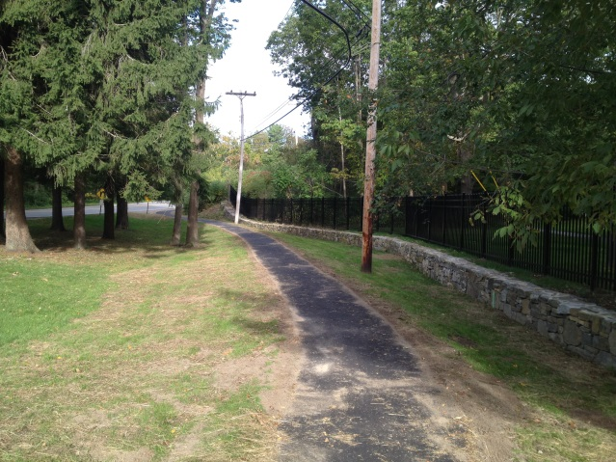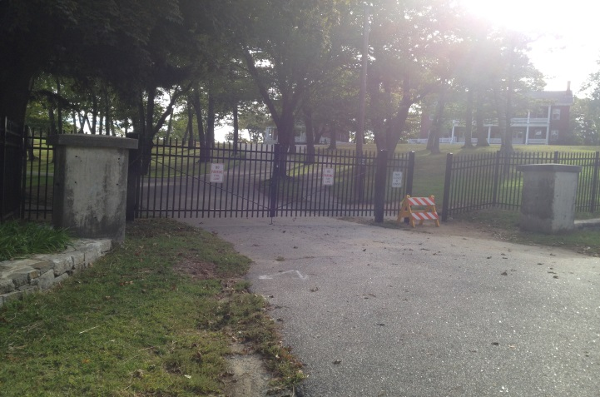

To the north of Portland Head Light other chain link fence was replaced with new more appropriate and safer fencing:

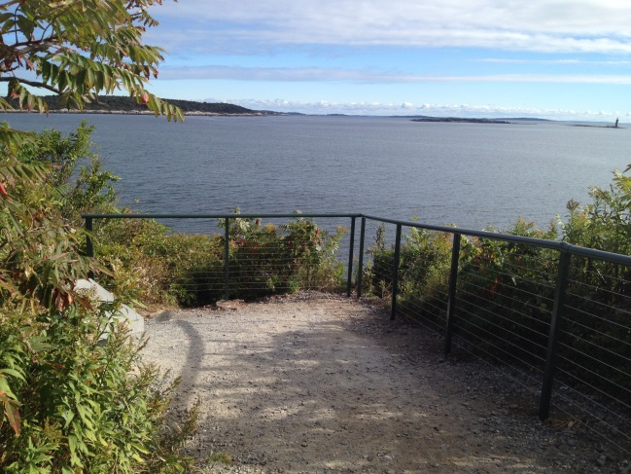
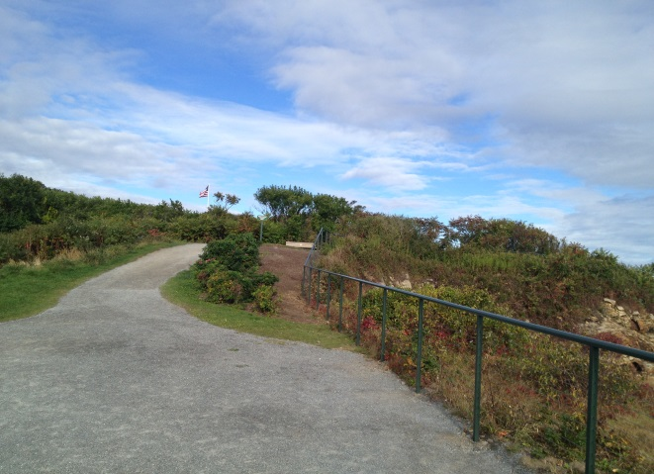

The Charles Road improvement project was completed.

Bids were received on a replacement backhoe/loader and came in under budget.

Interviews were conducted with library planning consultants and the firm of Richard Reed and Associates began work.

Work began on the next phases of the Cottage Brook subdivision which should lead to an uptick in the construction of single family houses. There are a total of 23 single family homes in the subdivision of which 4 were previously built. This is off Spurwink Avenue near the South Portland line.

A building permit was issued was a new Rudy’s and the former building was demolished.

Town reports for 2011 and 2012 have been printed and are available. The charter has been printed including the November 2012 amendments.

Engine Company One had its annual Labor Day weekend art show at Fort Williams Park.

The annual employee golf tournament was held at Purpoodock Club with about 25 participants. This tournament is done at no cost to the town and the Cape Elizabeth Police Association picks up some expenses for a gathering after the tournament. Employees pay a golf fee and use personal time to participate. Thank you to Mark Dorval who organized much of the tournament and to Jim and Evelyn Cox who hosted afterwards.

Attorney Kenneth Cole has scheduled separate meetings with neighbors and the gun club for input.

Looking Ahead

The Library book and bake sale will be October 18th and 19th.

The town center planning committee is hosting a forum on October 17th at 7:00 p.m. at the town hall.

Paper shredding will be available at the Recycling Center on October 19th from 9 a.m. to 1 p.m.

Fall Cleanup: Disposal fees at the Recycling Center will be waived for residents transporting their own material and/or items for two weeks in October, 2013. Fees will be waived from Saturday, Oct. 12 through (up to including) Monday, Oct. 28. Contractors however will be assessed fees in accordance with current regulations. In addition to the above dates, the Recycling Center will be open four Sundays between Oct. 20 and Nov. 10 for the disposal of recyclables, leaf, yard wastes, wood waste, bulky waste and brush only. Fees will be assessed on applicable items on Nov. 3 and Nov. 10.
Items normally destined for the transfer station compactor (household refuse) will not be accepted on Sundays.
Sunday, Oct. 20.............................................10:00 A.M. to 4:30 P.M.
Sunday, Oct. 27..............................................10:00 A.M. to 4:30 P.M.
Sunday, Nov. 3...............................................10:00 A.M. to 4:30 P.M.
Sunday, Nov. 10 ............................................10:00 A.M. to 4:30 P.M.

Debra Lane will update the council on October 7th on the availability of absentee ballots for the November 5th election.

